Basic Engine Parts

Basic Engine Parts
The core of the engine is the cylinder, with the piston moving up and down inside the cylinder. The engine described above has one cylinder. That is typical of most lawn mowers, but most cars have more than one cylinder (four, six and eight cylinders are common). In a multi-cylinder engine, the cylinders usually are arranged in one of three ways: inline, V or flat (also known as horizontally opposed or boxer), as shown in the following figures.
1) Inline - The cylinders are arranged in a line in a single bank.
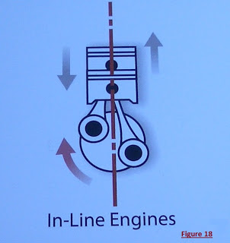
Figure 18 : In-line Engines

2) V - The cylinders are arranged in two banks set at an angle to one another.

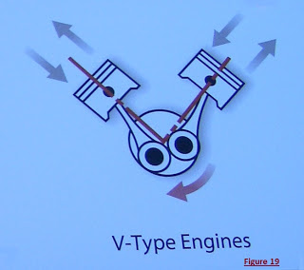
Figure 19 : V-type Engines

3) Flat - The cylinders are arranged in two banks on opposite sides of the engine.

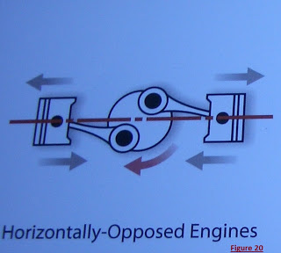
Figure 20 : Flat type Engines

Different configurations have different advantages and disadvantages in terms of smoothness, manufacturing cost and shape characteristics. These advantages and disadvantages make them more suitable for certain vehicles.

Spark Plug:
The spark plug supplies the spark that ignites the air/fuel mixture so that combustion can occur. The spark must happen at just the right moment for things to work properly. The spark plug has not really changed in 120 years. While there have been many introductions based on manipulation of the electrodes they are still limited to 50 watts of power & power ignite fuel.

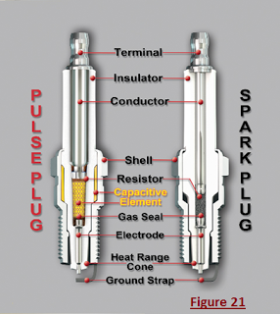
Figure 21 : spark plug and pulse plug.

Valves:
The intake and exhaust valves open at the proper time to let in air and fuel and to let out exhaust. Note that both valves are closed during compression and combustion so that the combustion chamber is sealed. Valve guides made of Bronze , Secured in the head by an interference (shrink) fit. Valve seats made of Chrome steel , stellite , or brass ; secured by interference fit.

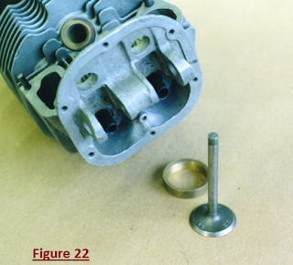
Figure 22 : Engine Valves

Poppet valves are the most common and get their name from the popping open and closed during operation. Intake valves are chrome steel and are cooled by the incoming air and fuel mixture. Exhaust valves are also alloy steel but are often filled with metallic sodium for cooling. Valve faces may be coated with Stellite to reduce wear and corrosion. Valve faces are ground to 30 degrees for intake (airflow) and 45 degrees (cooling) for exhaust.

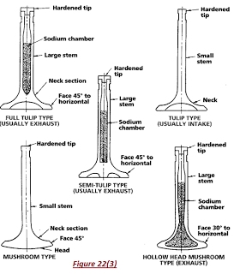
Figure 22(3) : Types of Valves.

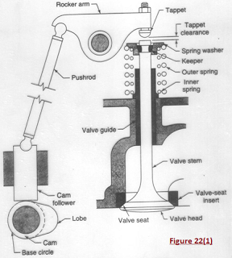
Figure 22(1) : Poppet Valve
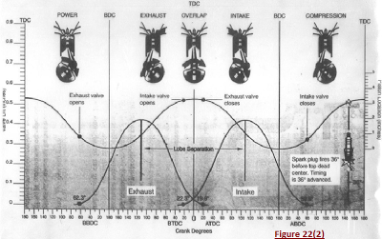
Figure 22(2) : Valve Timing profile.

Valve Springs :

Inner and outer springs are used to prevent bounce, provide redundancy, and increase valve closing pressure. Valve springs Held in place by retainer washers on the top and bottom of the spring. Split key or “keeper” holds the retainers and springs in place on the valve stem.

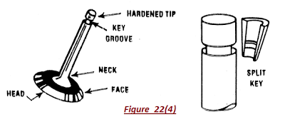
Figure 22(4) : Valve Springs.

Valve lifter or tappet :
Valve lifter or tappet may be solid, roller, or hydraulic. The lifter follows the cam lobes and pushes on the pushrod. Solid and roller lifters require adjustable rocker arms. Hydraulic type lifters fill with oil and lengthen to compensate for any clearances in the valve system.

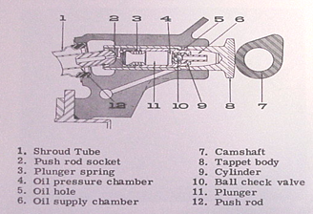
Figure 22(5) : Valve Tappet.

Piston :
A piston is a cylindrical piece of metal that moves up and down inside the cylinder. Pistons constructed of aluminium alloy. Parts include top , ring grooves , ring lands , skirt and piston pin boss. Cooling fins on the bottom help the oil carry heat away from the piston top.
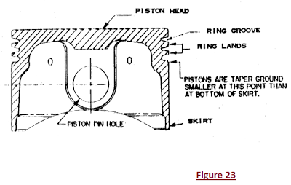
Figure 23 : piston

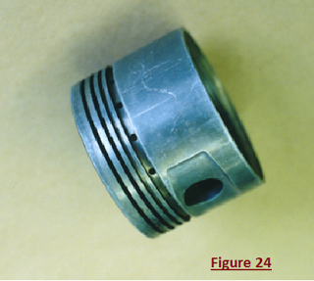
Figure 24 : piston

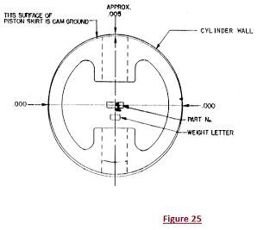
Figure 25 : piston

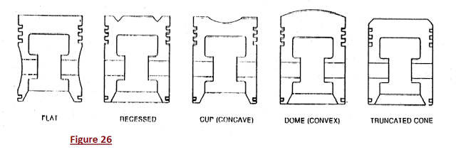
Figure 26 : Piston Head designs.

Piston Rings :

Piston rings provide a sliding seal between the outer edge of the piston and the inner edge of the cylinder. The rings serve two purposes:

- They prevent the fuel/air mixture and exhaust in the combustion chamber from leaking into the sump during compression and combustion.
- They keep oil in the sump from leaking into the combustion area, where it would be burned and lost.
- Most cars that "burn oil" and have to have a quart added every 1,500 kilometers are burning it because the engine is old and the rings no longer seal things properly.

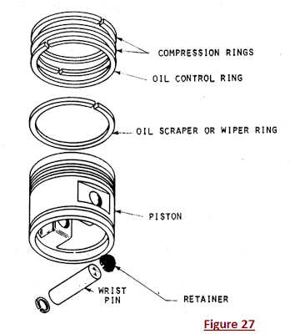
Figure 27 : Piston Rings.
Compression rings are located at the top of the piston and seal the combustion chamber. Types include rectangular, tapered , wedge.

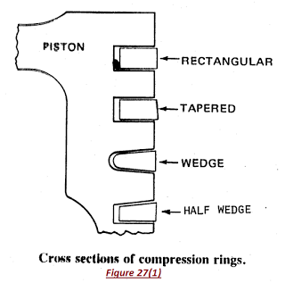
Figure 27(1) : Compression rings.

Oil control rings are located on bottom of piston below compression rings. It regulates oil film thickness on cylinder wall. Holes in ring and piston allow excess oil to drain back to crankcase. Too much oil film and the engine will use excessive oil and too little oil causes heat and insufficient lubrication.

Oil scraper rings direct the oil away from or towards the oil control rings depending upon the requirements of the engine.

Piston ring end gap is the gap at the end of the rings allows for expansion and contraction and unevenness in the cylinder wall. The types are butt, step and angle. Always stagger the end gaps during ring installation to prevent losing compression.

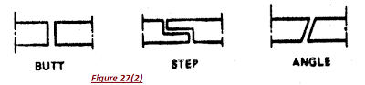
Figure 27(2) : Piston ring Joints.

Piston Pins (wrist pins) connects the piston to the end of the connecting rod. They are constructed of hardened steel. The pin is retained in the piston with clips or plugs to prevent cylinder wall scoring. Typically coming and Continental pins are free-floating, meaning the pin is not secured to the piston or the rod.

Connecting Rod :
The connecting rod connects the piston to the crankshaft. It can rotate at both ends so that its angle can change as the piston moves and the crankshaft rotates.

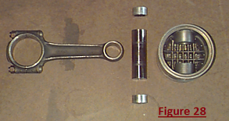
Figure 28 : Connecting Rod.

Connecting rod linked the crankshaft and piston. Normally it is made from steel , but some low powered engines use Aluminium to save weight. Cross section is an "H" or "I" shaped.
Types includes ,
- Plain rod.
- Fork and Blade rod.
- Master and Articulated.
Plain type rods
Plain type rods used on inline and opposed engines. Small bushing at piston pin end is pressed in place and reamed to final dimensions. Large end of rod includes a cap , bolts , nuts and plain bearing inserts. Rods are numbered as to cylinder and for cap-to-rod alignment.
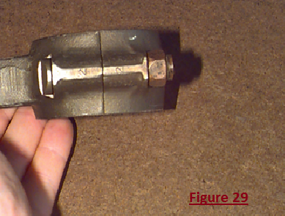
Figure 29 : Plain type rod.

Fork and blade connecting rod.

Fork and blade connecting rods are used on "V" type engines. One rod inside another allows cylinders to be aligned and to share a common location on the crankshaft.

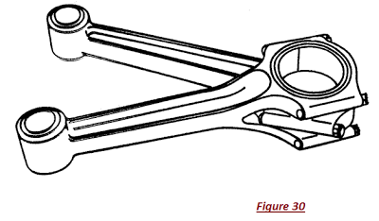
Figure 30 : Fork and Blade connecting rod.

Master and Articulating rod.

Master and Articulating rods are used on radial engines . Uses "Knuckle pins" to retain articulated rods to master.

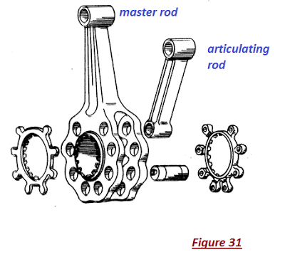
Figure 31 : Master and Articulating rod.

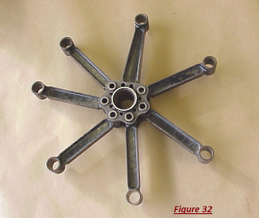
Figure 32 : Master/Articulating rods in action

Crankshaft :
The crankshaft turns the piston's up and down motion into circular motion just like a crank on a jack-in-the-box does.Crankshaft changes reciprocating motion of pistons into rotating motion to drive propeller. It constructed of chrome-nickel-molybdenum-steel. Crankshaft may be one piece or as many as three separate pieces. The propeller mounts to the front of the crankshaft using a spline, taper, or flange. The crankshaft rotates within the crankcase and is supported by main bearing journals. Crankshaft throws or crank pins are off center and account for the reciprocating motion of the pistons.

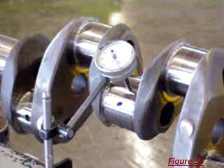
Figure 33 : Crankshaft main bearing journal , pin , arm.
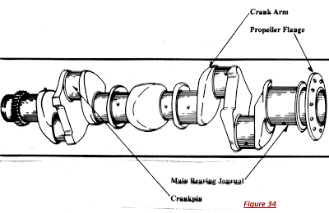
Figure 34 : Crankshaft.

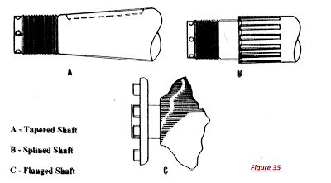
Figure 35 : Crankshaft ends for mounting propellers.

Dynamic Dampers can be mounted to the crankshaft to reduce vibration (floating). Counterweights are also used to reduce vibration but they are rigid and do not float. Counterweights and dampers are used in piston engines because the power pulses and movement of the pistons create large amounts of vibration. Vibration shortens airframe and engine life and can lead to premature component failure. The engine is also mounted in rubber bushings to absorb vibration.

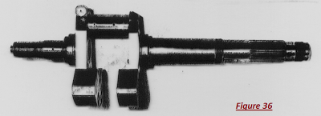
Figure 36 : Two piece crankshaft with counterweights.
(Single throw , single cylinder)

Sump:
The sump surrounds the crankshaft. It contains some amount of oil, which collects in the bottom of the sump (the oil pan).

Camshaft :
Cam shaft turns at 1/2 the speed of the crankshaft. It must be mechanically coupled to the crankshaft for timing purposes (gears, belts, chains). The camshaft consists of bearing journals and lobes spaced along the shaft. Each lobe is positioned to open and close a valve at a specific time.

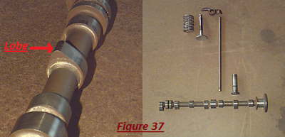
Figure 37 : Camshaft.

Push Rod :
Pushrod transmits push of lifter up to rocker arm. Hollow to allow oil to flow to the top of the cylinder for valve part lubrication. Length can be varied to adjust valve clearance. Valve clearance is the space between the top of the valve stem and the rocker arm. This clearance is to prevent a valve from being held open with the resulting heat build-up and loss of compression. Valve clearance increases as the engine operates due to cylinder expansion (solid lifters). Hydraulic lifters have a “0” clearance in operation.

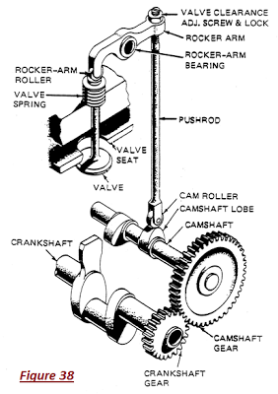
Figure 38 : Pushrod

Rocker Arm :
Adjustable in solid lifter engines and fixed in engines with hydraulic lifters. One end rests on the valve stem and the other on the pushrod. Rocking motion opens and closes the valves. Roller rocker arms incorporate a roller that reduces friction and are used in some radials and experimental engines.

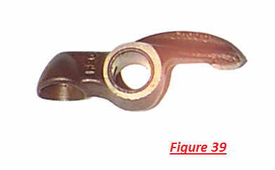
Figure 39 : Rocker Arm

Bearings :
Must be able to withstand forces inside an engine with minimal friction and heat build- up. Must accept radial and thrust loads.

Plain bearings :
A steel insert with babbitt (lead alloy) bonded to the bearing surface. Plain bearings are keyed to keep them in place. A lip or flange allows the plain bearing to accept thrust loads. Plain bearings are commonly used as crankshaft and rod bearings in opposed engines.

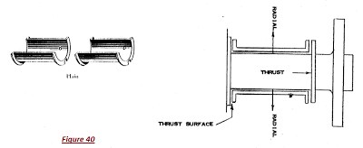
Figure 40 : Plain Bearings.
Roller Bearings (Anti friction) :
Hard steel rollers captured between an inner and outer “race” and held in alignment by a “cage”. It may be tapered to absorb radial and thrust loads or straight to absorb radial loads only.

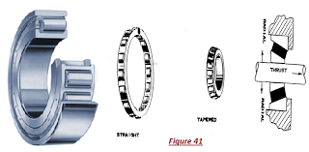
Figure 41 : Roller Bearings.

Ball bearings :
Ball bearings are used for both radial and thrust loads. Deep grooves in races allow thrust loads.

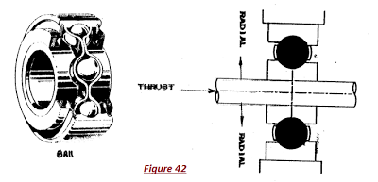
Figure 42 : Ball Bearing.

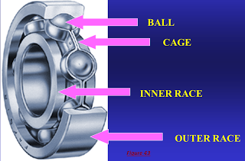
Figure 43 : Parts of a Ball Bearing.

